Smart Parking System
Dhruv Choudhary, Balaji P and Yashwardhan Khanna
Students at SRM Institute of Science and Technology, Kattankulathur, Chennai, India
Email: {yd7152, br8440, dr3515}@srmist.edu.in

Abstract
In the dynamically evolving urban landscape, where parking congestion and inefficiency present formidable challenges, our Smart Parking System stands as a revolutionary solution. Combining cutting-edge technologies such as computer vision, machine learning, and advanced data analytics, our system not only redefines the parking experience for users and administrators but also contributes to the broader goals of sustainable urban mobility. The core innovation lies in the deployment of a network of advanced smart cameras strategically placed for real-time occupancy detection. These cameras leverage complex computer vision algorithms, to analyse parking spaces dynamically. This ensures unparalleled accuracy in discerning real-time availability, considering factors like vehicle size, shape, and environmental conditions. The adaptive machine learning algorithms governing our system continuously evolve, learning from the dynamic urban environment. This continual refinement ensures robust and reliable occupancy detection, crucial for the effectiveness of our Smart Parking System. Users interact with our system through an intuitive mobile app, providing real-time availability checks, seamless reservations, and timely notifications. Simultaneously, administrators utilize a comprehensive dashboard, offering insights into parking utilization, revenue generation, user behaviour, and security monitoring.
Keywords: Smart parking, Computer vision, Machine learning, Occupancy detection, Urban mobility.

1.Introduction
The urban landscape faces escalating challenges in managing parking spaces efficiently. Rapid urbanization, coupled with increasing vehicular traffic, exacerbates parking congestion, leading to environmental degradation, economic inefficiencies, and diminished quality of life. In response to these pressing issues, our Smart Parking System emerges as a beacon of innovation, integrating cutting-edge technologies to revolutionize urban mobility. By harnessing the power of computer vision, machine learning, and advanced data analytics, our system offers a holistic solution to parking management, optimizing space utilization, reducing congestion, and contributing to sustainable urban development. This section provides an overview of our approach and its potential impact on urban mobility.
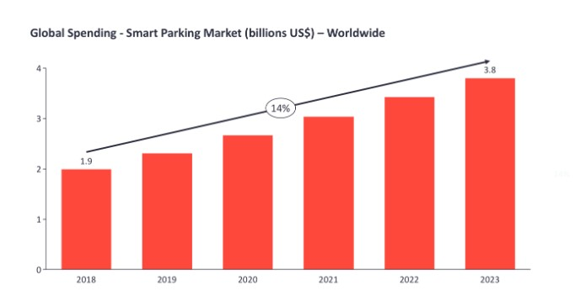
Figure 1: Figure description (TNR 10pt., centered, italics)

Source: https://iot-analytics.com/smart-parking-market-report-2019-2023/

Market spending for smart parking products and services is expected to grow at a CAGR of 14% and surpass $3.8B by 2023. These numbers are based on growing adoption across all regions and the analysis of distinct technological subsets of the smart parking market: the sensors, smart meters, digital signage, navigation and smart payment platforms. The penetration rate of “smart” parking spaces in the public domain (on-street and off-street) reached 11% in 2018 and is expected to reach 16% by 2023.

Services Provided
In the domain of occupancy detection, our system transcends traditional methods. Intelligent cameras act as vigilant observers, capturing and analyzing real-time data streams with unprecedented precision. Convolutional neural networks excel in pattern recognition, distinguishing between occupied and vacant parking spaces with a nuanced understanding of diverse scenarios. This adaptive learning mechanism ensures the system's resilience to evolving urban dynamics.

Our Smart Parking System offers a comprehensive suite of services aimed at enhancing user experience, ensuring security, and facilitating efficient parking management. These services include:
Real-time Availability Checks: Users can instantly check the availability of parking spaces through our mobile app, ensuring a hassle-free parking experience.
Seamless Reservations: The app allows users to reserve parking spots in advance, guaranteeing a parking space upon arrival.
Timely Notifications: Users receive notifications about parking availability, reservation confirmations, and reminders, enhancing convenience and reducing uncertainty.
Comprehensive Dashboard: Administrators access a dashboard providing insights into parking utilization, revenue generation, user behavior, and security monitoring. This enables data-driven decision-making and efficient resource allocation.
Security Monitoring: Our system incorporates advanced security features, including surveillance cameras, intrusion detection systems, and access control mechanisms, ensuring the safety and security of both users and vehicles.
The integration of these services ensures a seamless parking experience for users while empowering administrators with the tools needed to manage parking facilities effectively.

1.1.1 Dynamic Pricing Engine
The heart of our Smart Parking System beats with a dynamic pricing engine designed for scientific precision. Beyond considering mere occupancy rates, our pricing algorithm integrates a multitude of scientific variables. Seasonality, weather conditions, day-of-the-week patterns, and historical usage data all play integral roles in dynamically adjusting prices. Machine learning models predict user demand, allowing the system to optimize prices in real-time, contributing not only to efficient space utilization but also to the broader urban planning objectives.
The system's adaptive pricing strategy encourages users to choose less congested times, contributing to a more evenly distributed parking demand. This scientific approach aligns with sustainability goals, promoting a reduction in overall urban congestion and emissions.

Source: https://www.wallstreetmojo.com/dynamic-pricing/

2. Methodology
The methodology employed in the development and implementation of the Smart Parking System revolves around leveraging computer vision technology to optimize parking management and enhance urban mobility without the need for expensive sensors. The system architecture was meticulously designed to comprise three main components: smart cameras strategically deployed in parking areas, a central server responsible for data processing and analysis, and user interfaces including a mobile application for users and an administrative dashboard for administrators. These components interact seamlessly to enable real-time occupancy detection, dynamic pricing optimization, and user engagement.
Smart cameras were strategically positioned to capture real-time data on parking occupancy without the need for additional sensors. These cameras utilize computer vision algorithms to analyze images and classify parking spaces as occupied or vacant in real-time. Sophisticated techniques such as object detection and image segmentation were employed to achieve high accuracy and efficiency in occupancy detection. Data collection involved the regular capture of images from parking areas using smart cameras. These raw images were subjected to preprocessing procedures to enhance image quality and remove noise. Techniques such as image enhancement and noise reduction were utilized to ensure the accuracy and reliability of subsequent analyses.
The core of the Smart Parking System lies in its occupancy detection algorithm, which relies solely on computer vision techniques to analyze images and classify parking spaces. Machine learning algorithms were employed to train the occupancy detection model using labeled data, allowing the system to adapt and improve over time.

Predictive models for dynamic pricing optimization were developed using machine learning techniques. Various algorithms, such as decision trees and neural networks, were trained using historical data to predict future parking demand based on contextual factors such as time of day, day of the week, and weather conditions.
The dynamic pricing engine adjusts parking prices dynamically based on predicted demand and other contextual factors. A sophisticated pricing algorithm was developed to optimize prices in real-time, encouraging users to park during off-peak times and maximizing revenue for parking operators. The user interface design process focused on creating intuitive and user-friendly interfaces for both the mobile application and administrative dashboard. User experience considerations such as ease of navigation, visual appeal, and responsiveness were prioritized to ensure a seamless and engaging user experience.

2.1 Architecture
The architecture proposed in [2] for mAlexnet incorporates Local Response Normalization. However, recent quantitative experiments conducted by Z. Wang et al. [3] on the CIFAR-10 dataset demonstrated the superiority of batch normalization over local response normalization. In light of these findings, the present system adopts batch normalization layers instead of local response normalization layers (LRN) following the first two convolutional layers. The configuration for conv1-3 includes specifications for the number, size, and stride of filters, along with ReLU activation and batch normalization. Max pooling layers are indicated by their respective width, height, and stride values. Fully connected layers are defined by their dimensionality and activation functions. Padding is omitted for all layers. The modified architecture of mAlexnet implemented in the proposed system is detailed in Table 1.

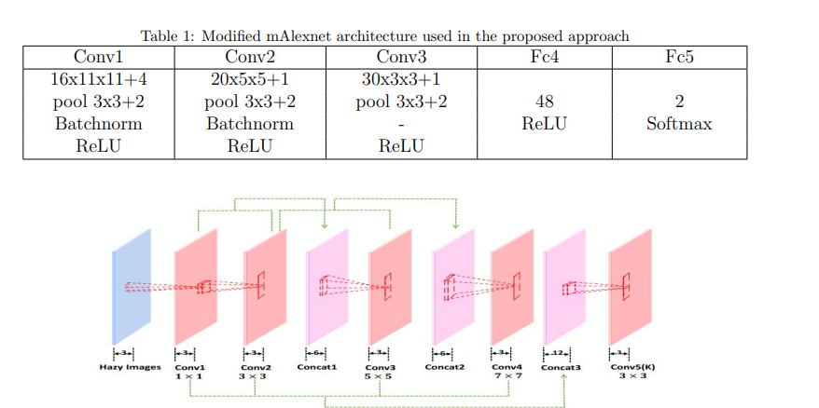
Figure 2: CNN Architecture

2.2 Parking slot availability detection
For each slot and video, the system renders the video frame by frame. It utilizes an input JSON file corresponding to each video to detect and validate slot occupancy based on changes in pixel intensity. If there's an increase in gray pixels, the slot is considered vacant; otherwise, it's deemed occupied. This process dynamically updates the availability status of each parking slot within each block, with color changes from RED to GREEN indicating shifts in occupancy. Additionally, a counter displays the ratio of available slots to total slots in real-time.

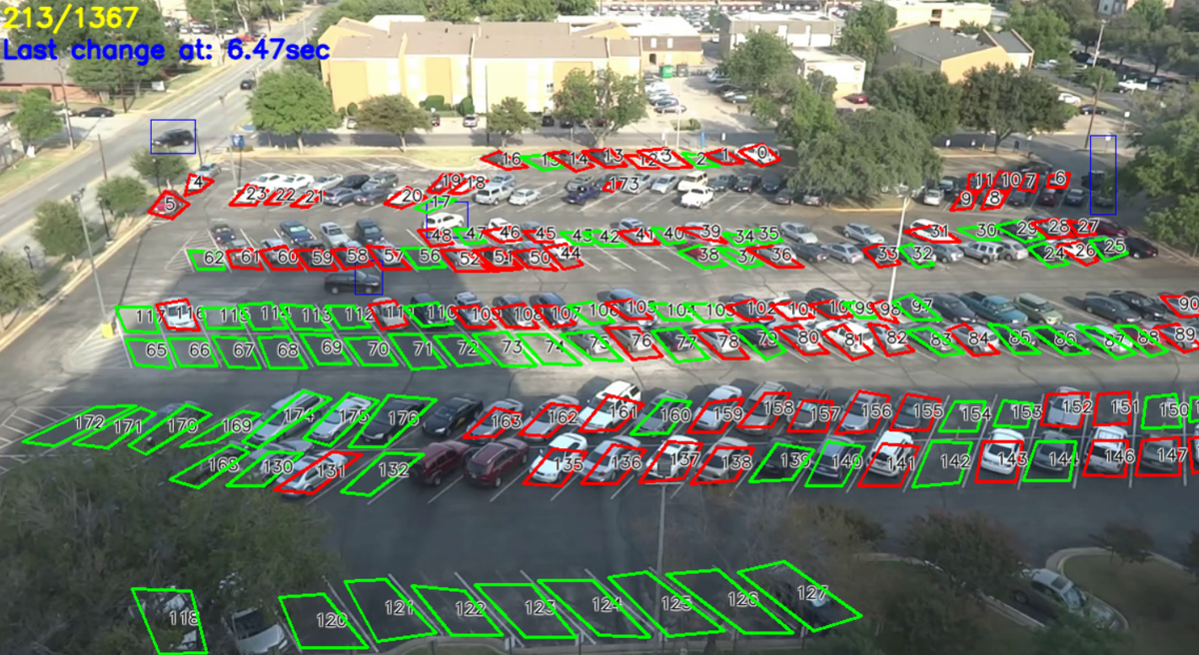
Figure 3: Detecting Parking Occupancy

Technically, numpy arrays store slot contours and pixel densities, derived from the RGB levels of pixels within each slot. These arrays are iterated over based on the JSON file, and occupancy checks are performed, reflecting changes on the screen. Updated numpy arrays reflect changes in occupancy properties for each slot. Video rendering occurs in a while loop, ensuring comprehensive frame-by-frame traversal. This meticulous approach guarantees no frames are overlooked, enabling thorough analysis of parking data and the identification of occupancy trends or projections for future slot occupancy rates.

2.3 Algorithm
The algorithm provides a systematic approach for the manual delineation of parking slots within an image by technical support personnel. It operates iteratively, enabling personnel to utilize cursors to mark the contours of individual parking slots. These marked contours are stored in a list, and the algorithm verifies whether the outlined lines form a rectangular shape, indicating a valid parking slot. Upon validation, the count of marked slots is incremented, and the pixel data corresponding to these slots is recorded for subsequent analysis. This iterative process continues until the personnel indicate completion, ensuring a thorough and meticulous identification of parking slots within the image, thereby facilitating accurate data collection and analysis for parking management purposes.

Algorithm for occupancy detection
action quit ← False
Marked lines ← []
Cnt of slots ← 0
while not actionquit != F alse do
M arked Lines ← Marked Lines + mark contour(cursor)
if formrect(M arked lines) != True then
Cnt of slots ← Cnt of slots + 1
storepixels(M arkedlines)
Marked lines ← []
end if
end while

3. Results
This System demonstrates a remarkable 86% accuracy rate in detecting parking occupancy, affirming its effectiveness in addressing urban parking challenges. Through the utilization of advanced computer vision algorithms and real-time data processing, the system efficiently analyzes images captured by smart cameras to discern between occupied and vacant parking spaces. This high level of accuracy ensures reliable and timely information for users, facilitating seamless navigation and reservation processes. Additionally, ongoing refinements and optimizations further enhance the system's capabilities, promising even greater accuracy and efficiency in managing parking resources and enhancing urban mobility.

4. Discussion
The successful implementation of the Smart Parking System underscores its potential for further expansion and refinement to address evolving urban mobility challenges. While achieving an impressive 86% accuracy rate in parking occupancy detection, there remains room for improvement and expansion of system capabilities. Future enhancements could include the integration of additional sensors or IoT devices to augment data collection and analysis, thereby increasing accuracy and reliability. Moreover, exploring machine learning techniques for predictive modeling could enable the system to anticipate parking demand patterns more effectively, optimizing resource allocation and enhancing user experience. Furthermore, collaboration with city planners and urban developers could facilitate the integration of the Smart Parking System into broader smart city initiatives, fostering sustainable urban mobility and improving quality of life for residents. By embracing innovation and collaboration, the Smart Parking System has the potential to become a cornerstone of smart urban infrastructure, contributing to more efficient and accessible parking solutions in cities worldwide.

5. Conclusion
Our Smart Parking System not only addresses immediate parking challenges but also establishes a new era in urban mobility. The combination of advanced computer vision, machine learning, and scientific precision in occupancy detection, dynamic pricing, and security features positions our system as a pioneer in the field. As we conclude, the transformative potential of our system extends beyond congestion alleviation, fostering efficiency, sustainability, security, and a seamless parking experience.

References
[1] Gaurav Satyanath, Jajati Keshari Sahoo, Rajendra Kumar Roul, Smart Parking Space Detection under Hazy conditions using Convolutional Neural Networks: A Novel Approach (2022) 6-8
[2] G. Amato, F. Carrara, F. Falchi, C. Gennaro, C. Vairo, Car parking occupancy detection using smart camera networks and deep learning, in: 2016 IEEE Symposium on Computers and Communication (ISCC), IEEE, 2016, pp. 1212–1217.
[3] Z. Wang, Z. Deng, S. Wang, Accelerating convolutional neural networks with dominant convolutional kernel and knowledge pre-regression, in: B. Leibe, J. Matas, N. Sebe, M. Welling (Eds.), Computer Vision – ECCV 2016, Springer International Publishing, Cham, 2016, pp. 533–548.

